Diabetes Campaign

‘Your Health: Diabetes - Know It. Check It.’ aims to close the awareness gap around Type 2 diabetes by helping people understand their personal risk, take simple steps to prevent it, and access local NHS support for testing and management - at every stage of life:

- Adults aged 40+
- People from South Asian, Black, or higher-risk backgrounds
- Those overweight or obese
- Those with a family history of diabetes
- People already living with Type 2 diabetes

GP practices play a vital role in early detection and prevention — from promoting the free online risk check and NHS Health Checks to supporting annual diabetes reviews and healthy living advice.

CAMPAIGN DATES November 2025

Why this campaign matters



POSTERS
These posters
can be displayed:

- In waiting rooms
- In consultation rooms
- On notice boards
- On social media posts
- On practice websites

Remember to laminate them first for use in public areas.

Your Diabetes – Know It. Check It.
November 2025

SOCIAL MEDIA
Diabetes Campaign
Your Health: Diabetes – Know It. Check It.

SOCIAL MEDIA
This guide provides clear instructions for GP practices on how to use the campaign’s social media content and assets to effectively reach Sheffield’s diverse communities and encourage early action on Type 2 diabetes.
You’ll find all the tools in this guide, including:
- Pre-designed social media posts for Facebook, Instagram, LinkedIn, and X (Twitter).
- Ready-to-use graphics aligned with the campaign’s central theme:
“Know Your Risk” – encouraging people to take the free Diabetes UK risk check, book a blood test, or attend their annual diabetes review.

1. Ensure Messages are Consistent
- Please use the exact wording provided in the campaign posts to ensure messages are accurate, inclusive, and consistent across all Sheffield GP practices.
- Practices may add a short local note such as:
“Book your blood test today at [Practice Name]”
or
“Find out more on our website.”
- Each post links to a clear action such as taking the risk check, booking a test, or arranging an annual review.

2. Where to Post
- Facebook, Instagram, and X (Twitter): Use the supplied posts to reach broad audiences and raise awareness about diabetes risk, prevention, and review checks.
- LinkedIn: Share posts that highlight your practice’s involvement in Sheffield’s public health campaigns.
- GP Practice Websites & Patient Portals: Reinforce messages with simple links to risk checks, Health Check booking pages, or NDPP referral information.

3. Timing & Engagement Tips
- Post regularly from 12 November to 12 December 2025, focusing activity around World Diabetes Day (Friday 14 November).
- Rotate content each week for variety and focus (e.g. Week 1 – Risk Check; Week 2 – Testing; Week 3 – Annual Reviews; Week 4 – Living Well with Diabetes).
- Tag partners such as @PrimaryCareSheffield, @DiabetesUK to increase reach.
- Engage positively - respond to comments or questions promptly, but never discuss personal medical details online.

Waiting Room & Reception Post
Purpose: Encourage patients to think about diabetes checks, prevention, and healthy living while they wait.
Talking points for your Reception staff:
- “You can take a free online Diabetes Risk Check - scan the QR code on our posters.”
- “If your results show risk, book a quick blood test at reception.”
- “If you already have diabetes, make sure your annual review is booked.”

Consultation Room Post
Purpose: Support GPs, nurses, and HCAs to reinforce diabetes awareness naturally during appointments.

Talking points for Clinicians:
- “Many people don’t know they’re at risk of diabetes - would you like to take a quick check?”
- “If you’ve not had a review in the last year, let’s get that booked in.”
- “Even small changes in diet and activity can make a big difference to your blood sugar levels.”

Next Steps for GP Practices
✅ Ensure all staff are familiar with the campaign’s core message: Know It. Check It.
✅ Share campaign posts across all practice social channels to increase visibility and encourage early testing.
✅ Monitor engagement, reply to general questions, and feedback any patient insights to PCS for shared learning.

Download & Upload
All campaign materials - including social media graphics, posters, in-practice video, web congtent and SMS captions - are available to download from the:
General Practice Communications Hub
👉 https://primarycaresheffield.org.uk/general-practice-communications-hub/

Social Media Post Guide
Social Media Post | Linked Image
🩺 Know Your Risk  Take the free 2-minute Diabetes UK risk check. Early action can prevent or delay Type 2 diabetes.  📱 Scan the QR code or visit riskscore.diabetes.org.uk  #KnowItCheckIt #SheffieldHealth | 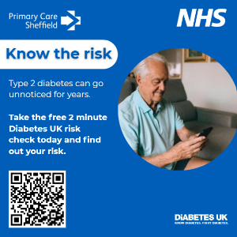
💉 Get Checked Early  Many people have Type 2 diabetes without knowing it. A simple blood test can tell you.  📞 Book your free NHS Health Check or HbA1c test today.  #KnowItCheckIt #PreventDiabetes | 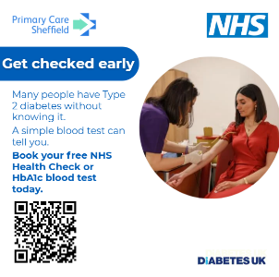
📅 Book Your Annual Review  If you’re living with Type 2 diabetes, your annual review keeps you healthy and prevents complications.  📞 Call your GP practice to book now. #KnowItCheckIt #StayWell | 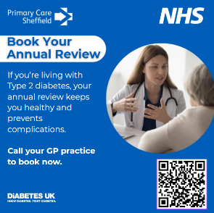
🥗 Small Changes, Big Difference  Healthy eating, being active, and checking your blood sugar regularly can reduce your risk.  💬 Ask your GP team about the NHS Diabetes Prevention Programme.  #KnowItCheckIt #HealthySheffield | 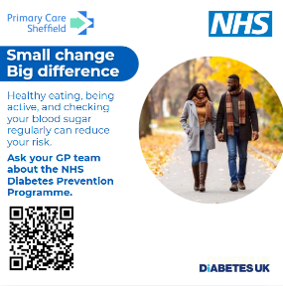
💉 Stay Well This Winter  🩹 Protect yourself - book your vaccination today.  #KnowItCheckIt #SheffieldHealth | 