RAMADAN and Diabetes Campaign
POSTERS
These posters
can be displayed:

- In waiting rooms
- In consultation rooms
- On notice boards
- On social media posts
- On practice websites

Remember to laminate them first for use in public areas.

11 February – 19 March 2026
POSTER GUIDE (Ramadan-specific)

Overview – How this poster is different
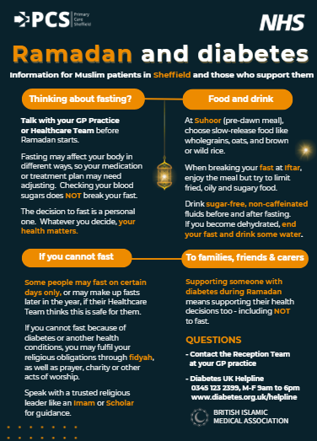
The Ramadan and Diabetes poster is a new, time-limited poster designed specifically for Ramadan 2026.

Unlike the Autumn 2025 Your Diabetes: Know It – Check It campaign, this poster does not focus primarily on diagnosis or general risk awareness. Instead, it supports safe decision-making, planning ahead, and GP conversations for people living with, or at higher risk of, diabetes during Ramadan.
It is designed to be used only during Ramadan 2026 and should not be treated as a continuation of the November diabetes campaign.

What this poster is for
This poster supports patients - particularly within Sheffield’s Muslim communities - who may be:
- living with Type 2 diabetes
- at higher risk of developing Type 2 diabetes
- considering whether or how to fast during Ramadan
- supporting a family member who is fasting
The poster encourages people to pause, plan, and talk to their GP practice before or during Ramadan.
What this poster encourages patients to do
The Ramadan & Diabetes poster encourages adults to:
- Think ahead about Ramadan and fasting
- Speak to their GP practice or healthcare team before Ramadan starts
- Understand that fasting can affect blood sugar levels and medication
- Know that checking blood sugar does NOT break the fast
- Book a diabetes review if they are already diagnosed
- Seek advice if they feel unwell, experience hypos, or struggle to manage their diabetes
This poster does not tell people whether they should or should not fast.
It reinforces that health-led decisions are personal and valid.

Purpose and design – Ramadan-specific focus

This poster is designed to:
- Act as a conversation starter during Ramadan
- Support culturally aware, respectful discussions in GP practices
- Reduce risk by encouraging early planning and safe choices
- Help staff respond confidently when patients ask about fasting and diabetes
- Complement — not duplicate — the Autumn diabetes risk campaign

The tone is supportive, non-judgemental, and faith-aware, avoiding clinical language or assumptions about fasting.

Display guidance – When and where to use it

Please display the Ramadan & Diabetes poster:
- In high-footfall areas such as GP receptions, waiting rooms, and corridors
- In consultation and nurse rooms as a prompt for Ramadan-related conversations
- On practice websites, digital screens, and social media channels during Ramadan only

This poster is most effective when displayed from mid-February until the end of Ramadan.

How this differs from the Autumn 2025 campaign

Autumn 2025:  Diabetes; Know It – Check It | Ramadan 2026:  Ramadan and Diabetes
General Type 2 diabetes awareness | Time-limited, Ramadan-specific
Focus on diagnosis and risk | Focus on fasting, safety, and planning
Risk check and blood tests | GP conversations and diabetes reviews
All adults | Muslim communities and those supporting them
Year-round relevance | Ramadan only – Feb - March 2026
Practices are encouraged to treat this as a distinct campaign with a different purpose.

Languages
The Ramadan & Diabetes poster is available in multiple languages commonly spoken across Sheffield’s Muslim communities: English, Arabic, Bengali, Gujarati, Urdu and Somali.
If your practice requires an additional translation, please contact PCS Communications
(usual turnaround within 36 hours.

Final reminder to practices
This is a new, targeted Ramadan campaign, not a repeat of the Autumn diabetes activity.
Your support in displaying and using this poster helps ensure patients receive timely, culturally appropriate guidance at a key point in the year.

